Bash Scripting

1. Create on Bash script to check if a directory is available or not.

Create a directory 🡪 mkdir -p /sushma/scripts

Create a file 🡪 chdrct

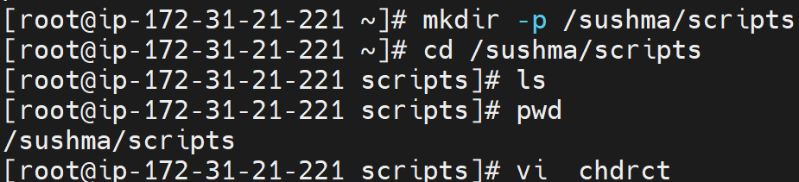

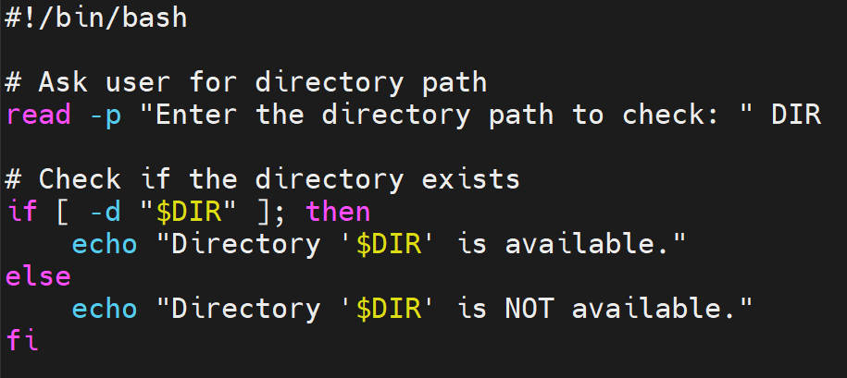

Save file 🡪Esc🡪:wq!

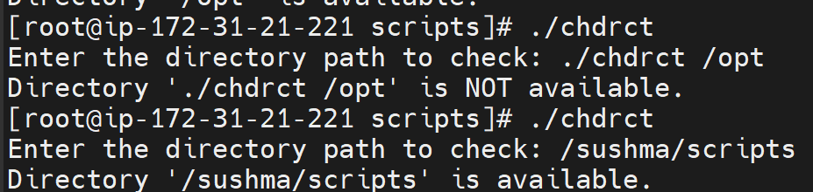

2) Create a bash script which will create multiple files.

Created a file called multif

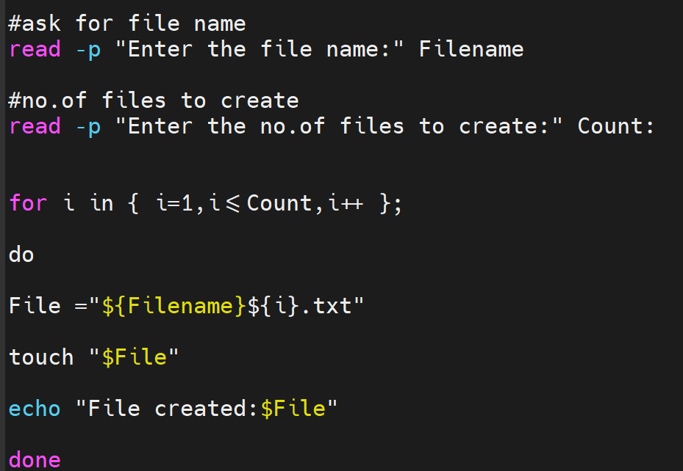

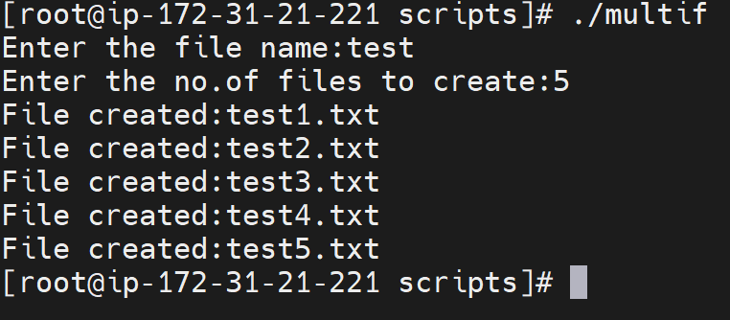

3) Create a bash script to take backup of a directory.

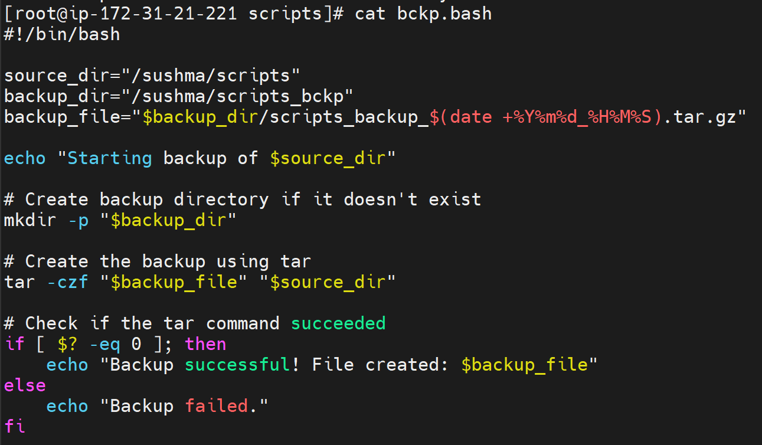





4) Create a bash script to install nginx in ec2 server.

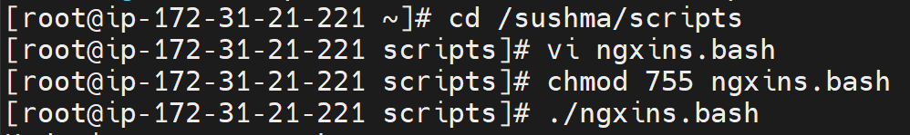

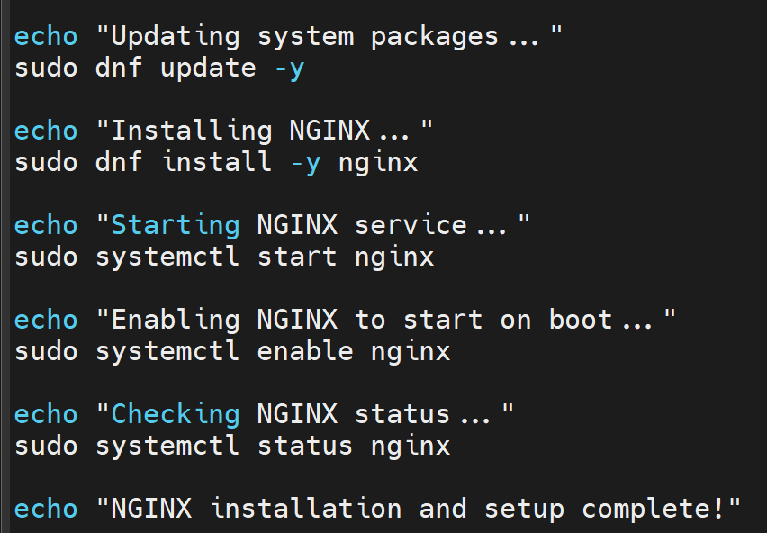

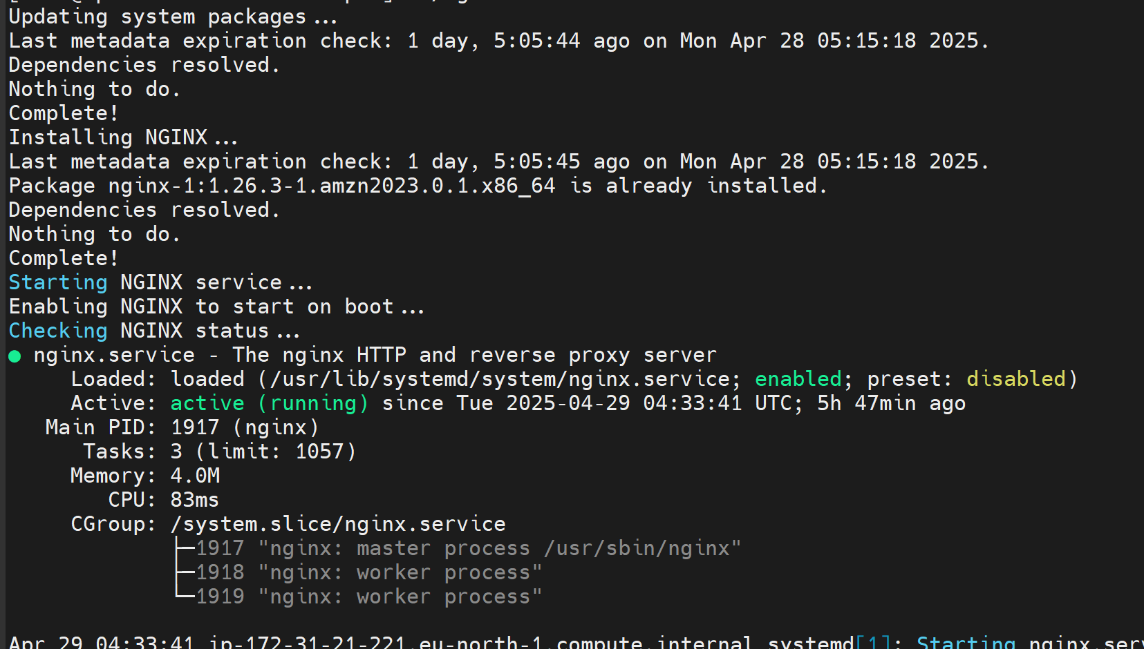

5) Create a bash script to install ApacheTomcat in ec2 server.

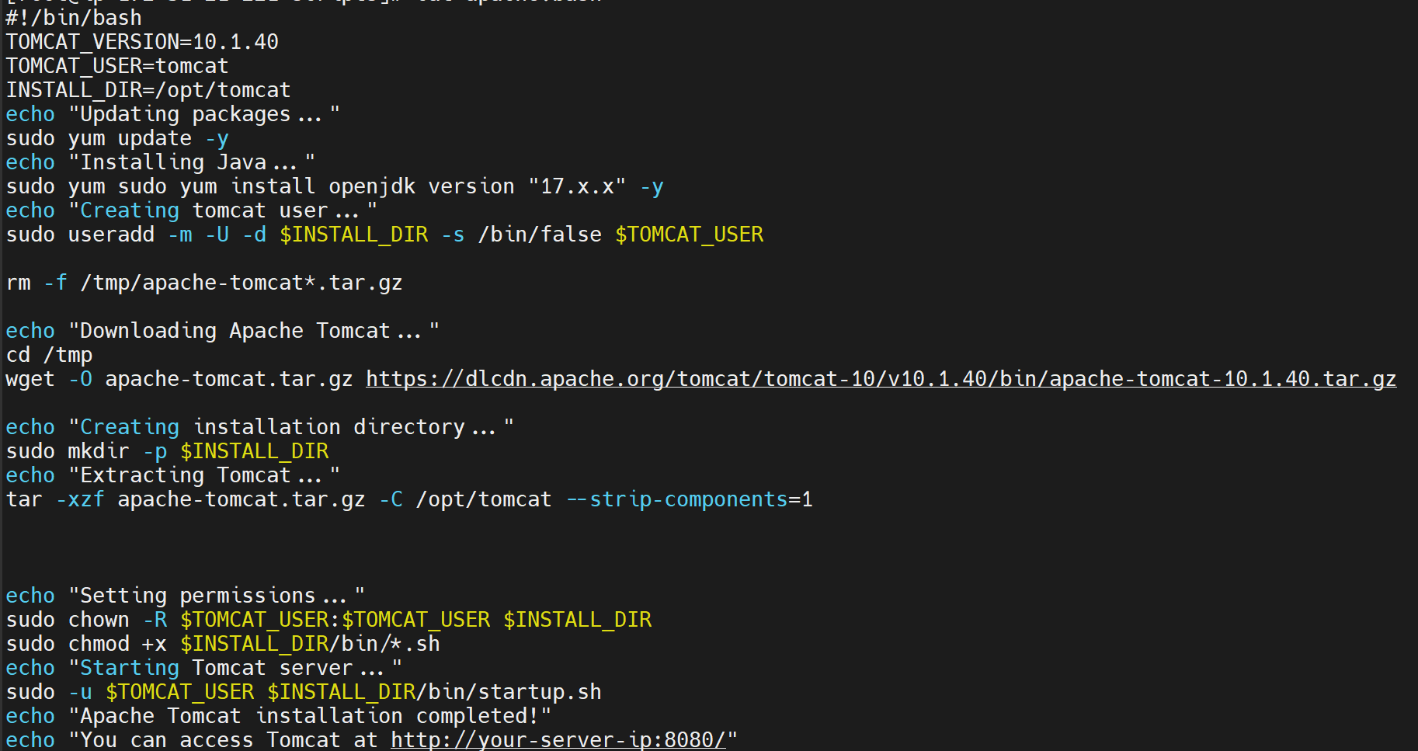

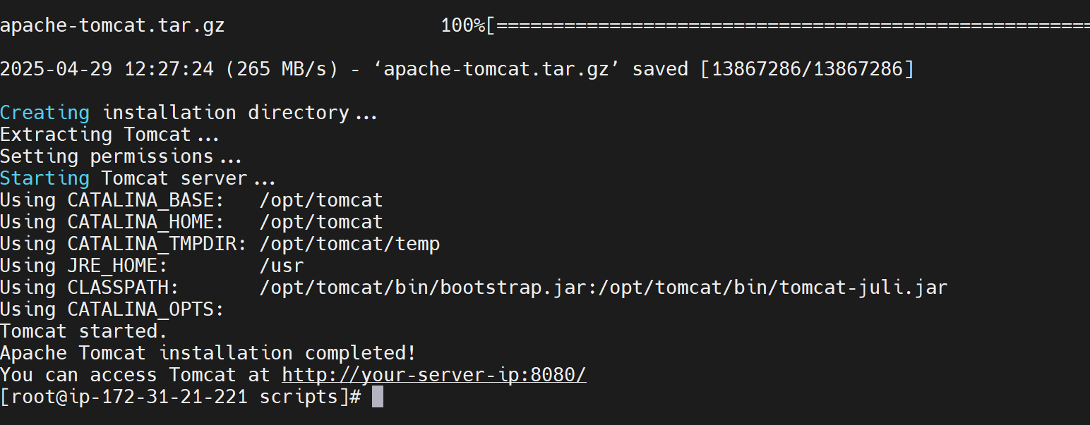

6) Create a bash script to check list if nginx service is running or not,if not running

then script should start the service.

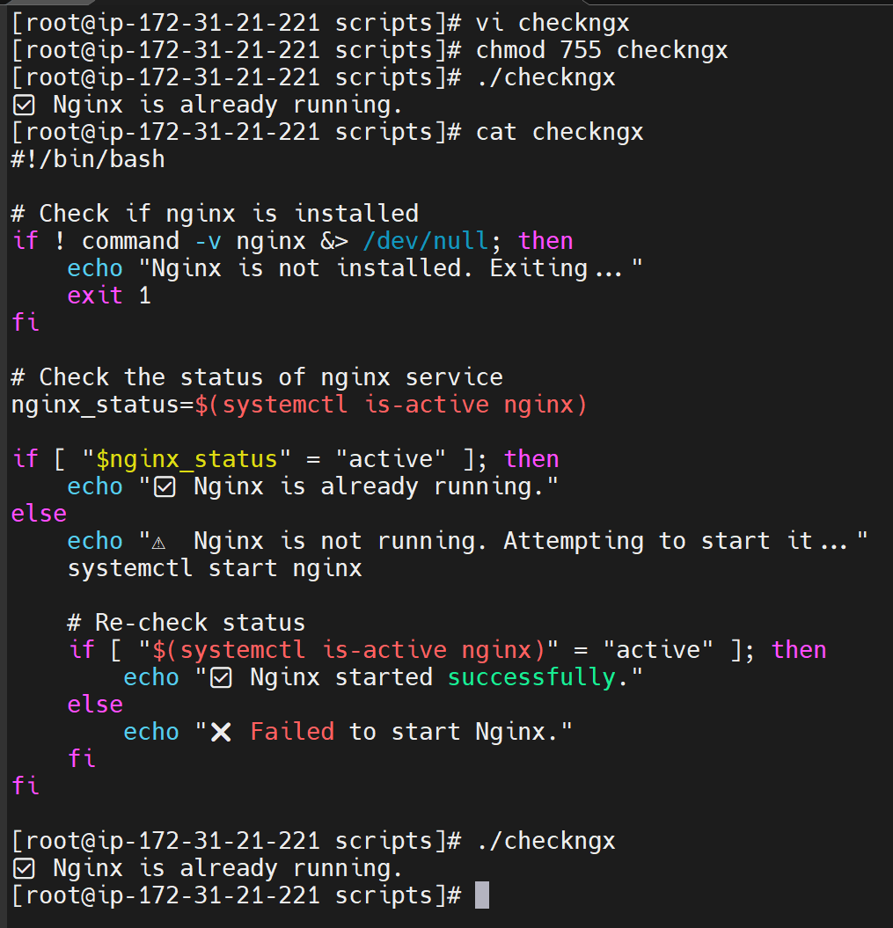

7) Create a bash script for calculator.

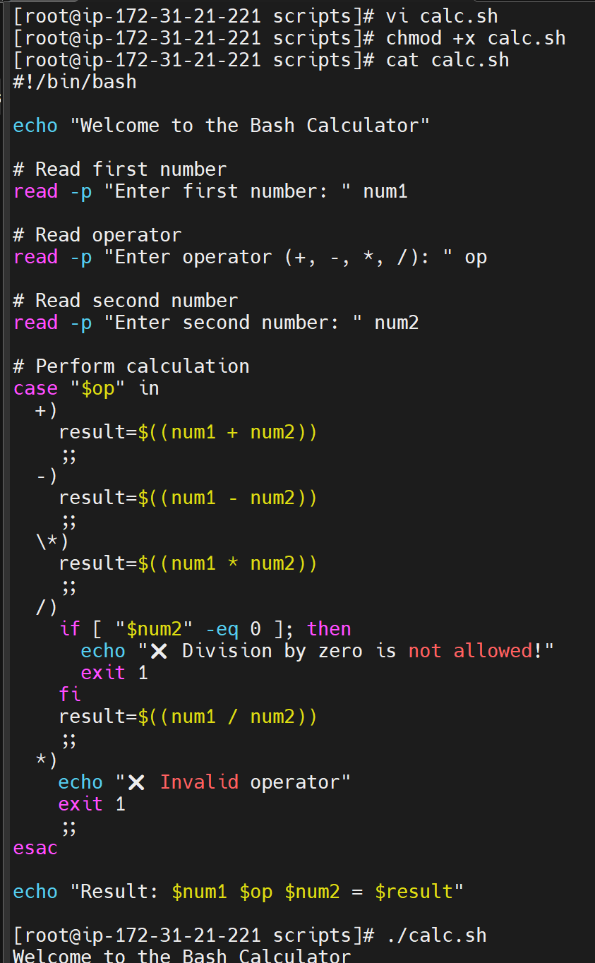

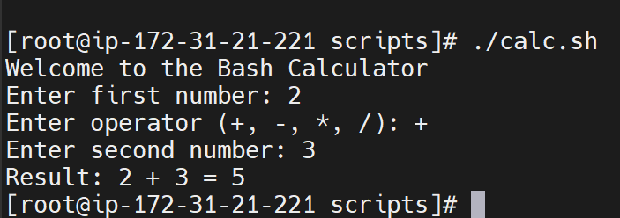

8) Create a bash script to check if directory is avaialble or not,if not then create a directory.

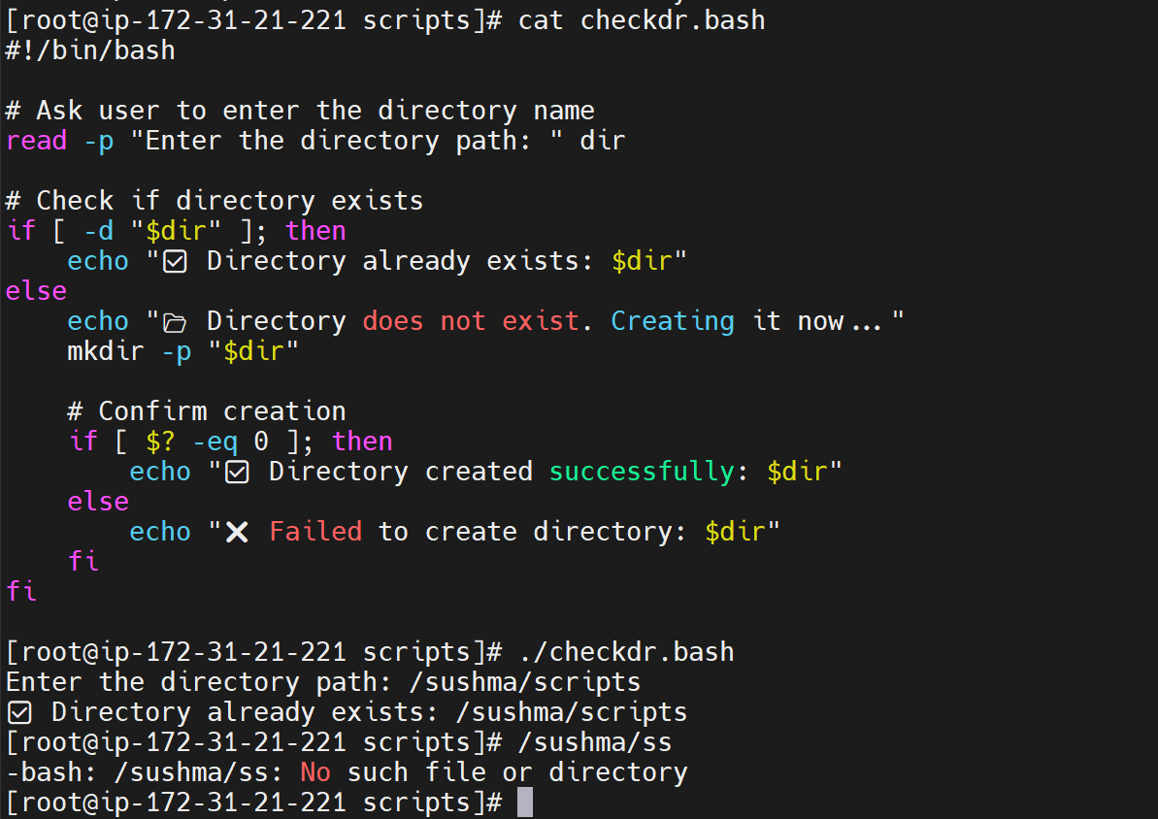

9) Create bash script to delete last 3 lines for a file.

